- At least 4 producers
- At least 2 decomposers
- A Total of at least 20 organisms
- Plan by creating at least 3 food chains and then see how they can combine to create a food web. Use arrows to show the flow of energy.
- Label all the organisms: herbivore, omnivore, carnivore, producer
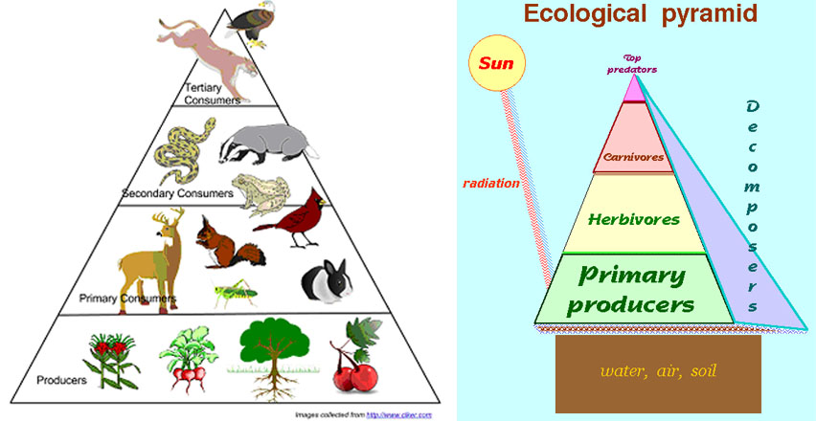
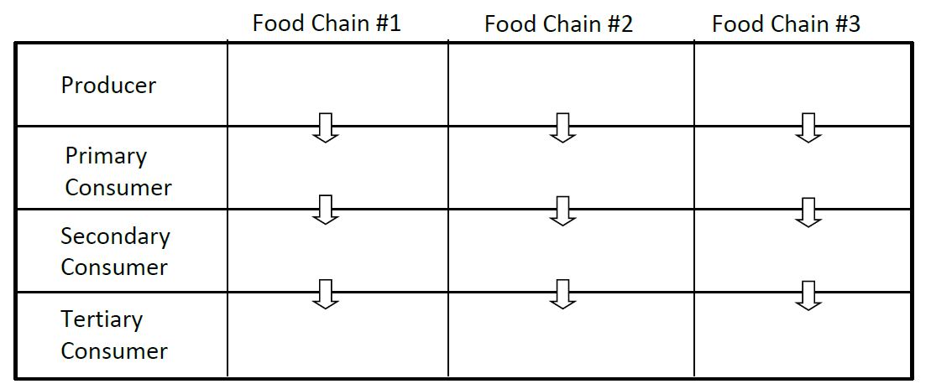
- On the back of your paper plan your food web by

Producers — bring energy from nonliving sources into the community
Primary consumers — eat the producers, which makes them herbivores in most communities
Secondary consumers — eat the primary consumers, which makes them carnivores
Tertiary consumers — eat the secondary consumers

